Project Name: Abu Ghaleb bridge
Location:
Contractor  Rowad Modern Engineering | Consultant  Penta | Employer  General Authority for Roads and Bridges
Project Code | 0167 | Date: | 28/12/2022 | Report No. | 62
Phase | 1 | Ref. |  | Attached doc.

A. Management Staff
(Input by Timekeeper)
ID | Position | Day Shift | Night Shift | Notes
1 | عمال ذاتى | 6
2 | كهربائى تركيبات | 1
3 | فورمجيه خرسانه | 5
4 | لحامين | 2
5 | شده معدنيه | 0
7 | مساحه | 1
8 | مشرفين | 1
9 | الصحة والسلامة | 2
10 | مشرف امن ادارى | 1
11 | امن ادارى | 4
12 | مخزن | 1
13 | مشتريات | 1
14 | عامل سكن | 1
15 | مراقب وقت | 1
Totals of management staff |  | 32

B. Site Workers (Labors)
(Input by Construction Manager)
ID | Trade / Position | Subcontractor/Supplier Name | Location | No. of workers | Day Shift | Hours |  | Night Shift | Hours |  | Notes
1 | Steel fixing | Sherbieny |  | 3 | ☐ |  |  | ☐
2 | Formwork | Gohary |  | 6 | ☐ |  |  | ☐
3 | Pile head demolishing | Mohamed Saber |  | 0

C. Activities on Site
(Input by Project Control Engineer in coordination with Construction Manager)
ID | Location | On site activities description | Date |  | % complete previous | % Complete this day | To date % complete | Notes
 |  |  | Started | Planned Completion
1 | Axis-P10-P12 | حفر و صب خازوقين | 25/12/2022 | 28/12/2022 | 100 | 100 | 100 | جارى حفر وتسليم خازوقين واجمالى الصب 162 خازوق
2 | P04 | حدادة العمود | 11/10/2022 | 28/12/2022 | 20 | 0 | 20
3 | P03 | حدادة العمود | 12/10/2022 | 28/12/2022 | 20 | 0 | 20
4 | P02 | حدادة العمود | 12/10/2022 | 28/12/2022 | 30 | 0 | 30
5 | P20 | صب العمود | 16/11/2022 | 28/12/2022 | 95 | 5 | 100
5 | P22 | صب العمود | 16/11/2022 | 28/12/2022 | 80 | 5 | 85
6 | P23 | شدة العمود | 04/12/2022 | 28/12/2022 | 80 | 0 | 80
7 | P36 | حدادة القاعدة | 28/12/2022 | 28/12/2022 | 0 | 20 | 20
8 | P35 | حدادة القاعدة | 22/12/2022 | 28/12/2022 | 50 | 20 | 70
9 | P34 | حدادة القاعدة | 23/12/2022 | 28/12/2022 | 30 | 20 | 50
11 | P33-P34 | تكسير رؤوس خوازيق | 17/12/2022 | 28/12/2022 | 80 | 20 | 100 | تم ترتيب التكسير يوم السبت القادم

D. Equipment and tools list
(Input by Equipment Supervisor)
ID | Equipment  (heavy/small tools) | Subcontractor Name | Type  (Rented/owned) | Model | In use hours | Stand by hours | Notes
1 | 2 Loader | Mobilization | Rented |  | 8
2 | Tractor | Removal | Rented |  | 8
3 | Excavator | Excavation | Rented |  | 8
4 | Mobile crane | Mobilization | Rented |  | 8
6 | 3 Water truck | Piles | Rented |  | 8

Formwork
(Input by Formwork)
ID | Item Description | System | Subcontractor Name | Items Code | QTY | Location | Notes
1 | ------------
2

F. Delivered Material
(Input by site QC)
ID | Material description | Material on site (Qty)  if applicable | Delivered Qty  Today | MIR No. | Supplier | Notes

G. Area of Concerns
(Input by Project Control Engineer)
ID | Concern description  (i.e., weather condition, delay, obstructions) | Duration | Location | Impact | Notes
1 | Shortage of concrete supply from ready mix stations (Payment issue, availability of sim 3) |  | General | Delay of piles works & Claims from driller on site | Settled
3 | Mockup of mass concrete not started |  |  | Delay of all mass concrete works (Especially Pile caps) | Poured 24/9/22
5 | All requirements for Pile cap works ( Thermo cables-Earthing Drawing -qualified station for mass concrete) |  | Piles Caps |  | Settled
6 | Pier forms |  |  | Delay of pier works | Deliverd
7 | Bearings vendor not determined |  |  | Delay of piers & pier head
8 | Forms of U-precast beam is top urgent to be procured |  |  | Delay of project as it’s critical activity.
9 | Removal of 6 Residential buildings |  | P13-P19 | Delay of piles works
10 | Removal of Water station fence |  | P5-P8 | Delay of piles works

Prepared by: Approved by: Approved by:
Project control engineer Construction Manager Project Manager

Signature Signature Signature

Date Date Date

H. Site photos:
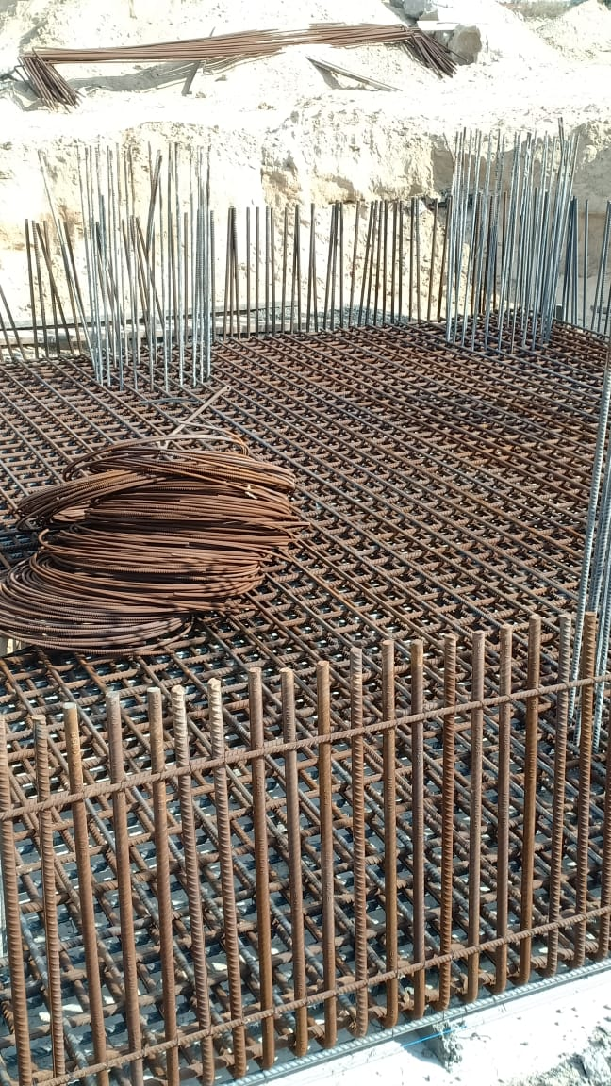
Steel fixing of pile cap P-35
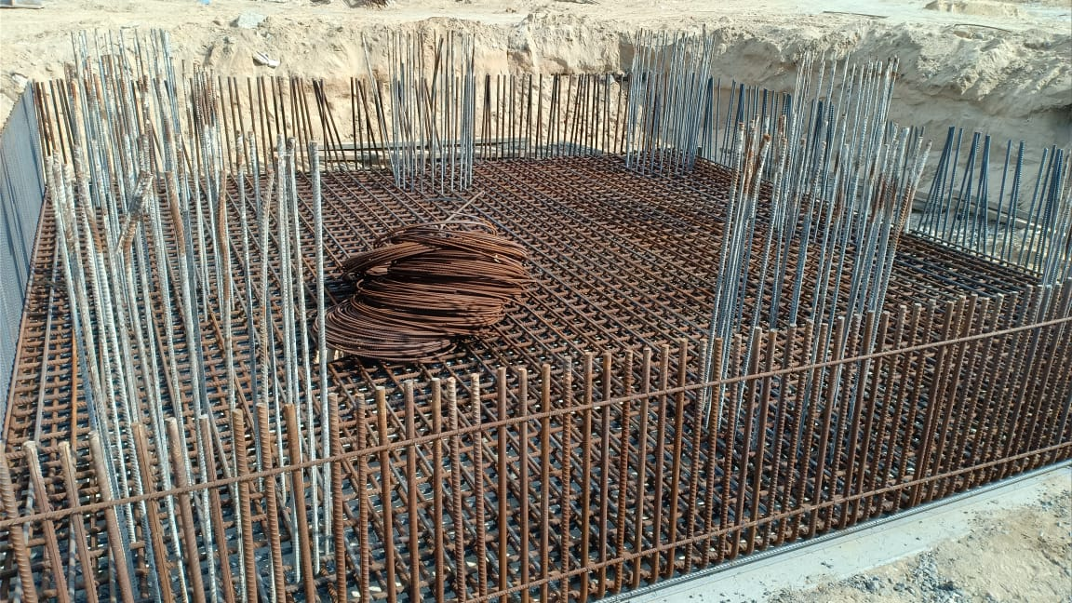
Steel fixing of pile cap P-35
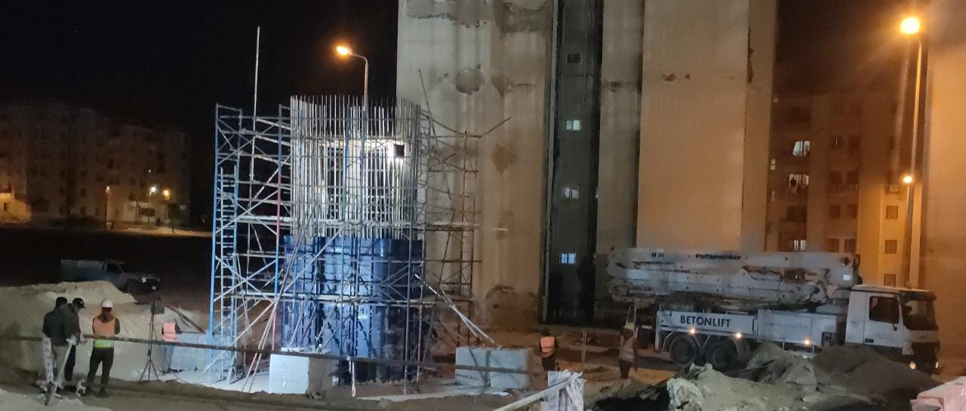
Pouring of column P-20
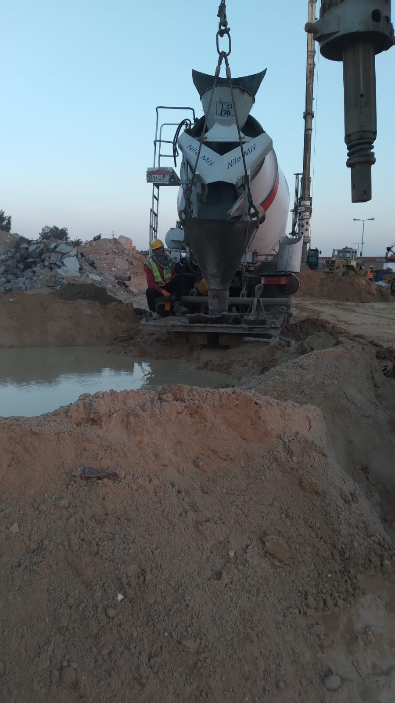
Pouring piles P19-P12

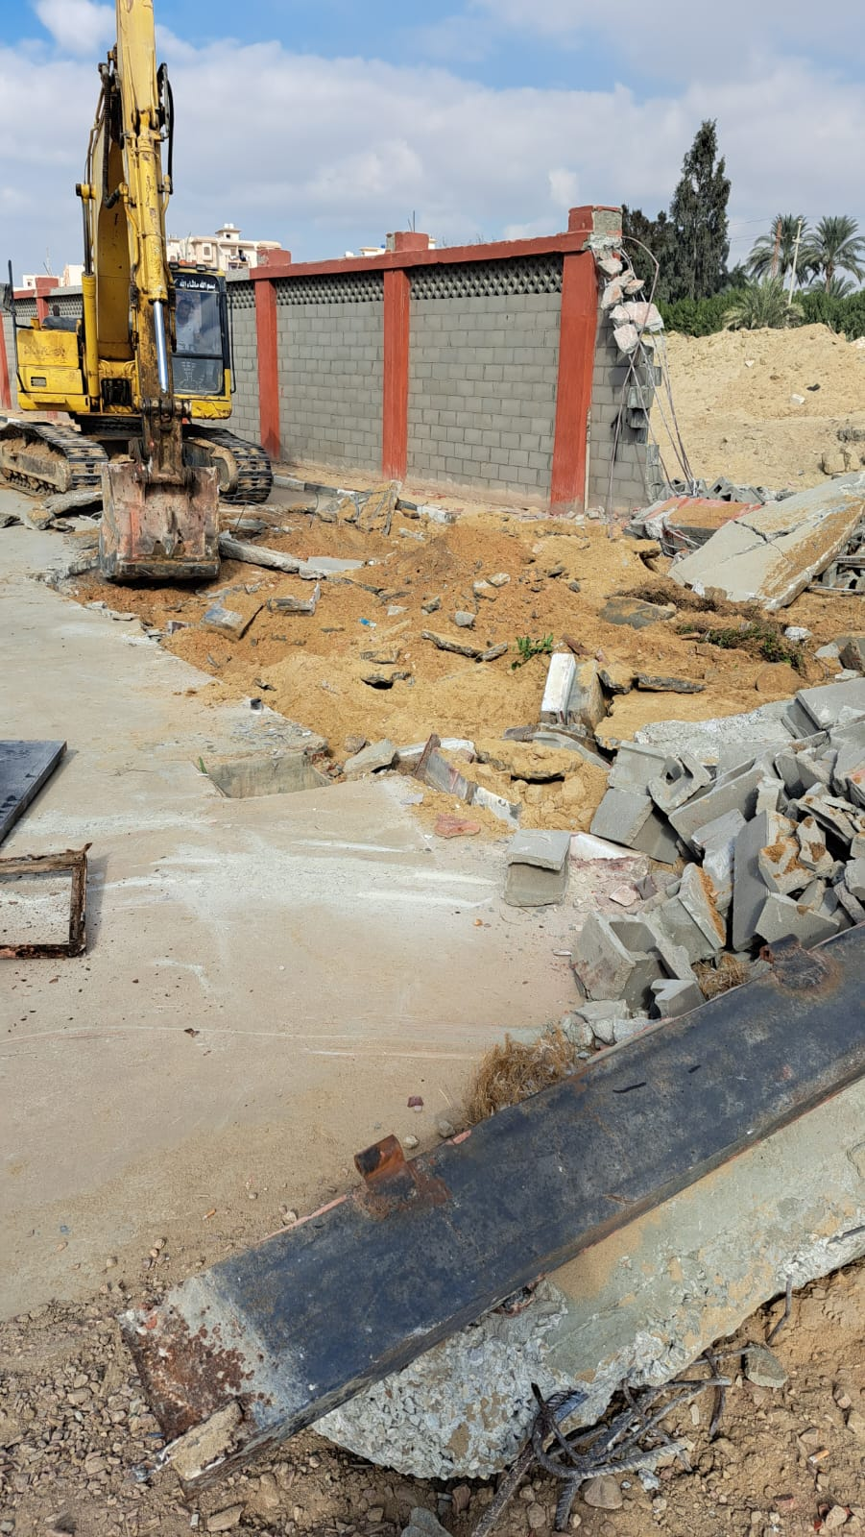
Demolishing Water station fence for piles work

